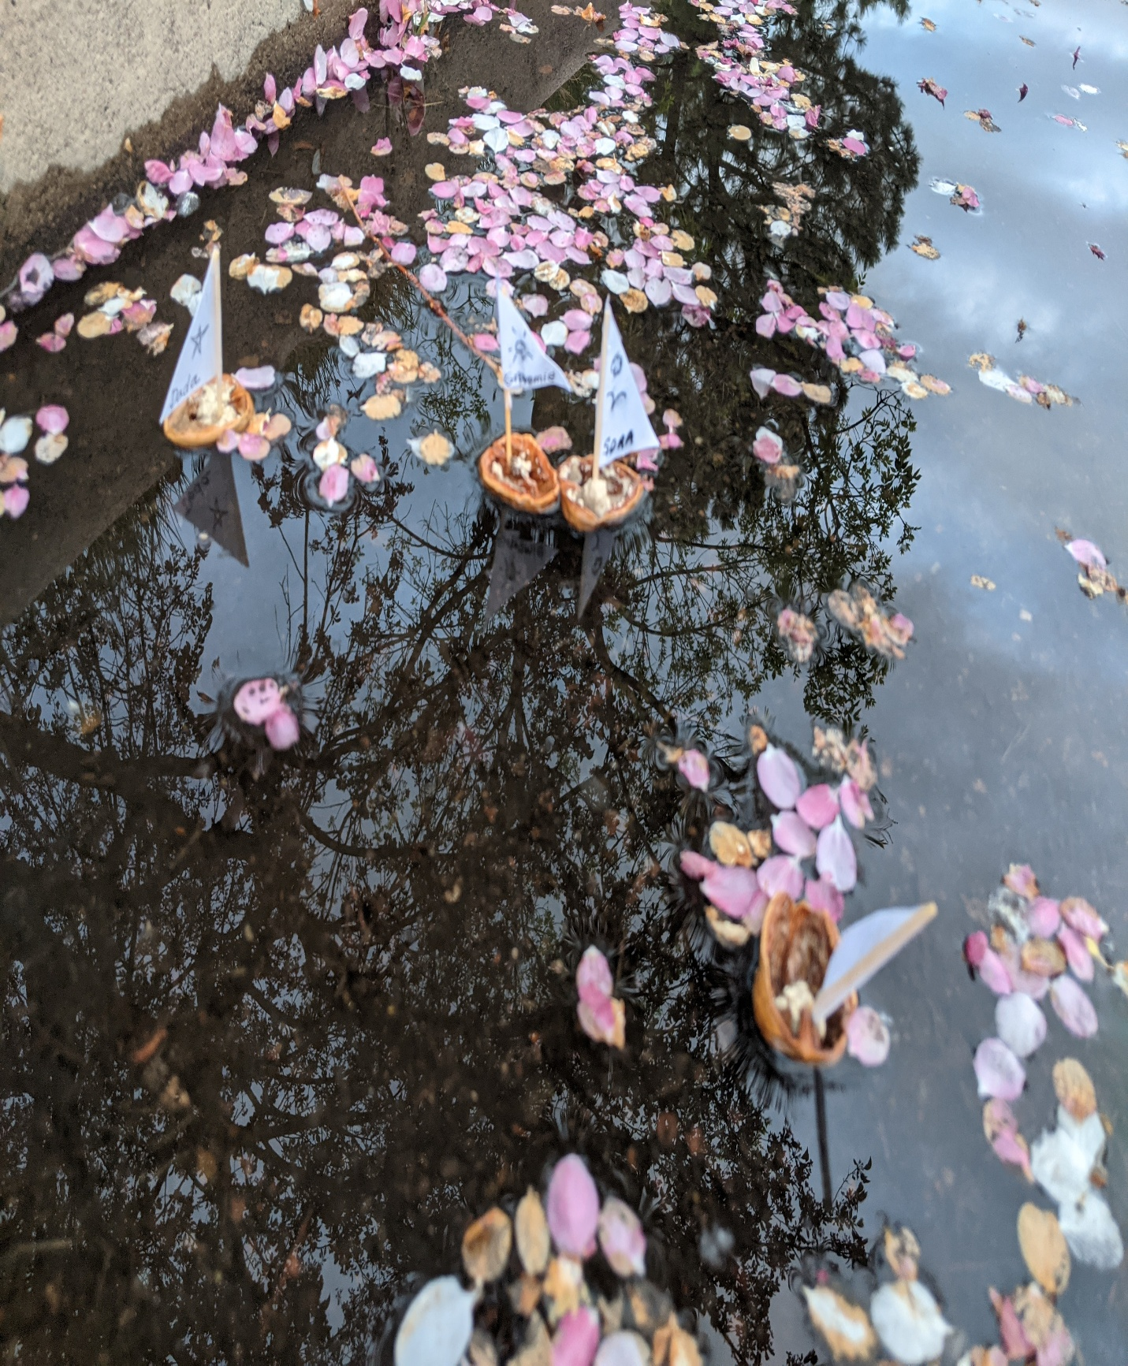
I was invited on a sailing trip through part of the inside passage north of Vancouver, British Columbia, and for that time I was also traveling in the liminal, the numinous. I traveled to where earth meets the ethereal, where day meets dream.
This sequence in fifteen short parts was written during that time.
The chapbook ends with a note about The Fire. So much begins and ends with climate change.
I made the chapbook to share because most people want to spend some time experiencing mystery and hope—
all the stuff the poems do better than I do writing explanatory notes.

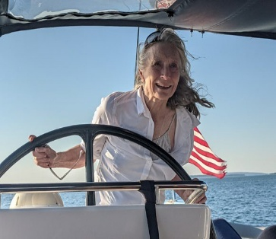
Folks know there are infinite ways to measure success. I have been loved, a lot, and have loved a lot. And all that love is going on more than ever. I have survived some dreadful events, so everything now is gravy, as my husband and I like to say. I am happy that I have had lots of poems published in journals, some of great renown, some less known and also excellent (American Poetry Review, Pilgrimage, The Missouri Review, Roanoke Review, e.g.), and I hav published 3 books of poetry: Tablewalking at Nighthawk (Ghost Road Press 2005, WILLA award); Chained Dog Dreams (finishinglinepress 2019); and Bright Path Dark Water (CAL finalist, 2020). I have gotten to read so so so much and widely; I never expected that I would fully appreciate having been a literature/writing teacher with a PhD in English/Creative Writing (Denver University). But I do, I do. In preschools to grad schools, from a town of 200 to prisons, I have thrived on celebrating reading and writing. carolgmpoetry.com cdgmurphy@gmail.com
Inside Passage

